In Java, a block is a group of statements enclosed within curly braces {}. There are different types of blocks in Java, including static blocks, instance initializer blocks, and constructors. Each has its own specific use case and execution order.
Types of Blocks in Java
- Static Block:
  - A static block is used to initialize static variables and is executed when the class is loaded into memory.
  - It is defined using the static keyword followed by a block of code.
  - It runs only once, regardless of how many instances of the class are created.
- Instance Initializer Block:
  - An instance initializer block is used to initialize instance variables and is executed each time an instance of the class is created.
  - It is defined without any keywords and is placed within the class body.
  - This block runs before the constructor every time an object is created.
- Constructor:
  - A constructor is a special method used to initialize objects.
  - It is called when an instance of the class is created and can take parameters to initialize instance variables with specific values.
  - Constructors can have multiple forms (overloading) and are defined without a return type.

Execution Order
The execution order of these blocks is crucial for understanding how Java initializes variables and objects:
- Static Block(s):
  - Executed first when the class is loaded into memory.
  - All static blocks in the class are executed in the order they appear in the class definition.
- Instance Initializer Block(s):
  - Executed every time an instance of the class is created.
  - All instance initializer blocks are executed in the order they appear in the class definition, before the constructor.
- Constructor:
  - Executed after all instance initializer blocks when an instance of the class is created.
  - The constructor initializes instance variables with specific values passed during object creation.

*Why This Order?
- Static Block Execution: Static blocks are executed first because they are used to initialize static variables and perform static setup tasks. Since these are associated with the class itself and not with any instance, they must be initialized when the class is loaded.
- Instance Initializer Block Execution: Instance initializer blocks are executed before the constructor to ensure that any common setup tasks for instance variables are completed before the constructor runs.
- Constructor Execution: The constructor is the last to execute because it may rely on the initializations done by the instance initializer blocks. It finalizes the creation of the object, often using parameters to set instance variables.

Example:
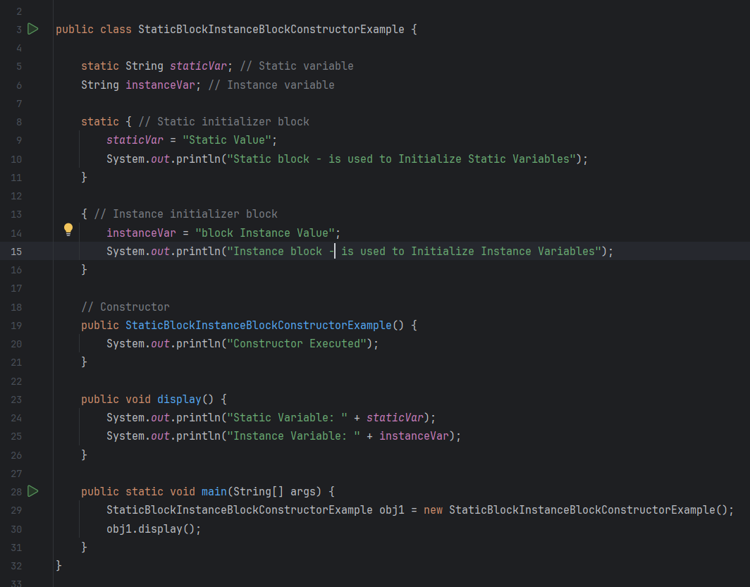
Output:
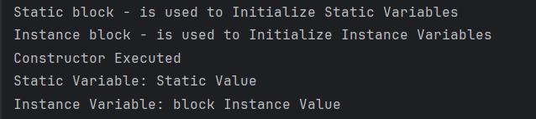
Summary
- Static Block: Initializes static variables, executed when the class is loaded.
- Instance Initializer Block: Initializes instance variables, executed before the constructor each time an object is created.
- Constructor: Finalizes the creation of the object, executed after instance initializer blocks.

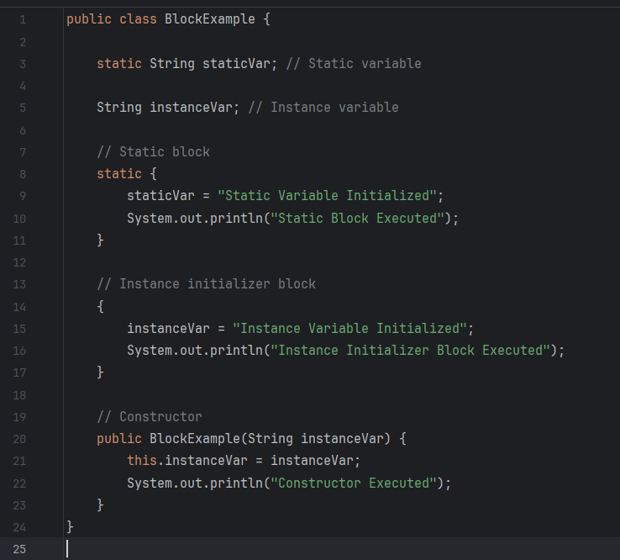
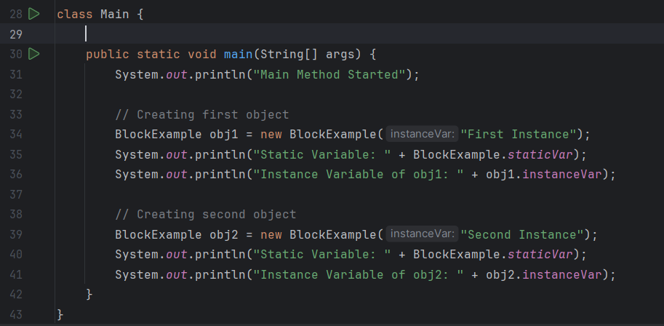

Output:
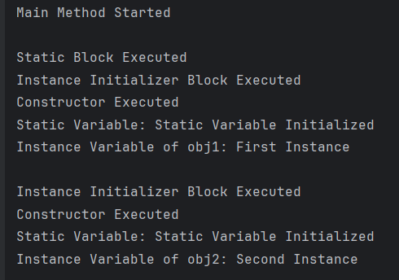

Instance Method vs Static Method
Instance Method: Tied to an instance of a class, can access instance variables and methods.
- Definition: An instance method is associated with an instance of a class.
- Access: It can access instance variables and instance methods directly.
- Invocation: It is called on an object of the class.
Instance Method Example:
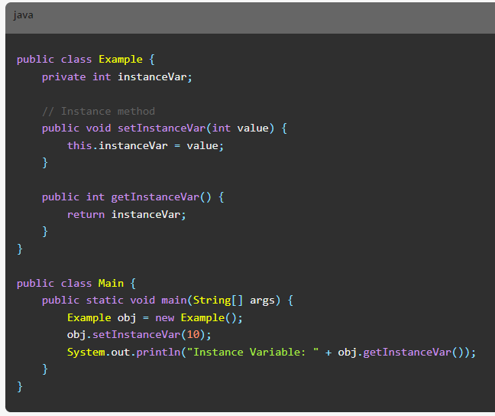

Static Method: Tied to the class itself, can access static variables and methods, used for utility functions, factory methods, singleton patterns, and static configurations.
- Definition: A static method is associated with the class itself rather than any particular instance.
- Access: It can access static variables and other static methods directly. It cannot access instance variables or instance methods directly unless it has an object reference.
- Invocation: It is called using the class name.
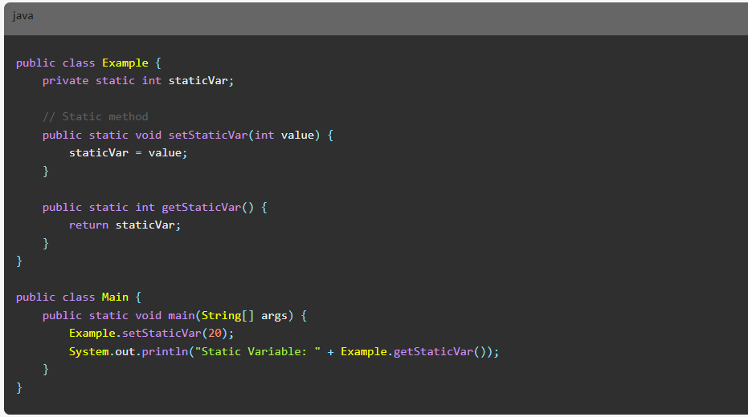

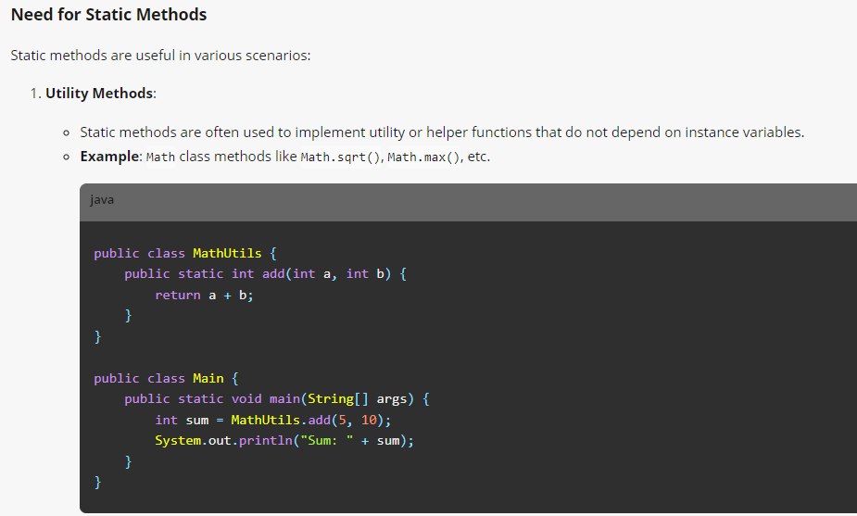
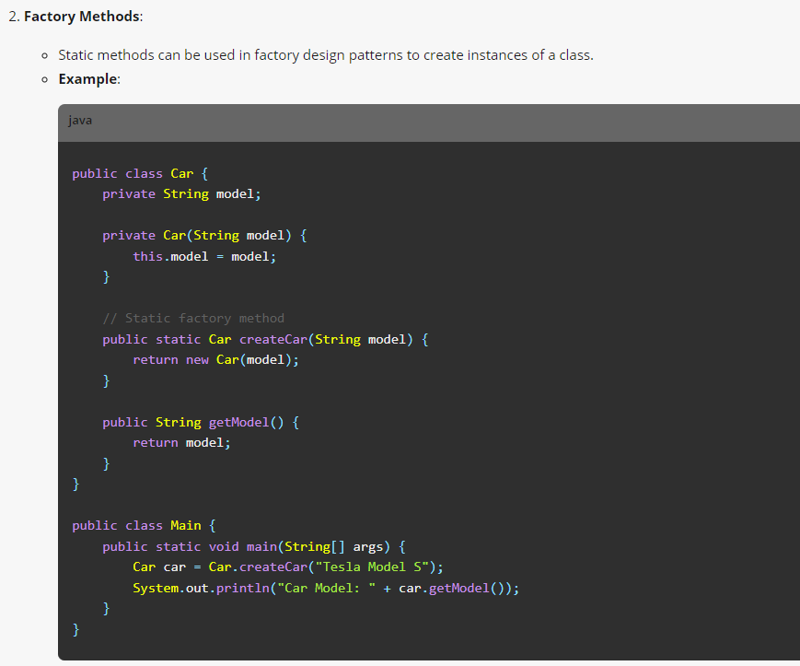

The Singleton Pattern is a design pattern that ensures a class has only one instance and provides a global point of access to that instance. This pattern is useful when exactly one object is needed to coordinate actions across the system.

